BRACT's
Vishwakarma Institute of Technology, Pune
Practical Implementation Sheet
Department: CSE-AI Semester: 5 Academic Year: 2026-27
Division: E Batch: 3 Practical No: 5
Roll no: 73 PRN No: 12415152 Name of Student: Pranav Upare
Subject Name : Deep Learning
Problem Statement
This practical extends the earlier single-model (LSTM-only) sentiment analysis submission on the Amazon Alexa Reviews dataset (3,150 verified customer reviews of Amazon Echo/Alexa devices, each labelled 0 = negative or 1 = positive feedback) by implementing and comparing three different recurrent architectures — a plain SimpleRNN, an LSTM, and a GRU — on the identical preprocessing pipeline, train/test split, and class-weighting scheme. The goal is to build all three deep learning sequence classifiers under matched conditions and evaluate them using accuracy, precision, recall, F1-score, confusion matrices, and training curves, in order to draw conclusions about how gating (LSTM/GRU) compares with a vanilla RNN on this real, imbalanced dataset (91.9% positive vs. 8.1% negative reviews).
Algorithm
1. Load the Amazon Alexa Reviews dataset (3,150 reviews; columns rating, date, variation, verified_reviews, feedback) and drop the single row with a missing review, leaving 3,149 usable reviews.
2. Clean each review by lowercasing the text and removing all non-alphabetic characters with a regular expression, collapsing repeated whitespace.
3. Use the existing binary “feedback” column directly as the sentiment label (1 = positive, 0 = negative).
4. Fit a Keras Tokenizer (vocabulary capped at 5,000 words, out-of-vocabulary token ‘<OOV>’) on all cleaned reviews, convert every review to an integer sequence, and pad/truncate (“post”) all sequences to a fixed length of 60 tokens.
5. Split the padded sequences and labels into training (80%) and testing (20%) sets using stratified sampling so both splits preserve the original ~92%/8% positive/negative class ratio.
6. Compute class weights (inversely proportional to class frequency) on the training labels to counter the 92%/8% imbalance during training.
7. Build three Sequential models that share an identical Embedding layer (32-dimensional) and a Dropout(0.3) + Dense(1, sigmoid) output head, differing only in the recurrent layer used: a SimpleRNN(32), an LSTM(32), and a GRU(32).
8. Compile all three models with the Adam optimizer and binary cross-entropy loss.
9. Train each model separately for 8 epochs with batch size 32, using a 10% validation split from the training data and passing the same class weights, so all three models see the same data under the same conditions.
10. Evaluate all three trained models on the same held-out test set using accuracy, a full classification report (precision/recall/F1 per class), and a confusion matrix; then compare all three side by side using a grouped bar chart and overlaid training curves.
Analysis
1. The dataset is real and heavily imbalanced: of 3,149 usable reviews, 2,893 (91.87%) are positive and only 257 (8.13%) are negative. The stratified 80/20 split gave 2,519 training reviews and 630 test reviews, preserving this ratio (class weights computed as {0: 6.14, 1: 0.54}).
2. The three models are deliberately matched in every respect except the recurrent layer, so differences in performance can be attributed to the recurrent cell type rather than to preprocessing or capacity differences elsewhere: total trainable parameters were 162,113 (RNN), 168,353 (LSTM), and 166,369 (GRU) — the gated cells add roughly 4,000–6,000 extra parameters over the plain RNN for their gating mechanisms, out of which the 160,000-parameter Embedding layer dominates all three.
3. Training behaviour differed noticeably across the three models. The SimpleRNN's validation accuracy was highly unstable, swinging from 92.1% (epoch 1) down to 56.0% (epoch 4) before recovering to 86.1% (epoch 7) — a classic symptom of a plain RNN struggling to hold a stable gradient signal over 60-token sequences. The LSTM likewise showed a sharp instability, peaking at 93.65% validation accuracy at epoch 3 but then spiking to a validation loss of 1.38 at epoch 5 before partially recovering — consistent with overfitting on a small, heavily imbalanced training set. The GRU was comparatively the most stable of the three, ending training at 90.65% train accuracy and 92.06% validation accuracy with a smoothly decreasing validation loss (0.42) in the final epoch, suggesting it generalised most reliably under identical training conditions.
4. On the held-out test set (630 reviews, 579 positive / 51 negative), overall accuracy rose steadily with the more sophisticated architectures: 80.63% (RNN) → 83.17% (LSTM) → 91.43% (GRU). Because 91.9% of the test set is positive, a trivial always-positive classifier would already score ~91.9% accuracy, so accuracy alone is not sufficient to judge these models — precision, recall, and F1-score on the minority (negative) class tell the more informative story.
5. Looking at the negative class specifically: the RNN correctly caught 26 of 51 negative reviews (51% recall) with 21% precision; the LSTM caught 25 of 51 (49% recall) with 24% precision; the GRU caught only 14 of 51 (27% recall) but with the highest precision (45%) of the three. In other words, the GRU traded negative-class recall for a large gain in overall accuracy and positive-class F1 (0.95) — it is the most accurate model overall but the least willing to flag a review as negative, while the RNN and LSTM are noisier but comparatively more willing to flag negative reviews, at the cost of many more false positives (25–26 each) among the negative predictions.
6. The confusion matrices make the trade-off concrete: RNN [[26,25],[97,482]], LSTM [[25,26],[80,499]], GRU [[14,37],[17,562]]. Moving from RNN/LSTM to GRU cuts false negatives (missed positive reviews misclassified as negative) from ~80–97 down to just 17, which is what drives the large accuracy and positive-F1 gain, but it comes at the direct cost of missing more true negative reviews (37 vs. 25–26 false positives on the negative row). Which model is “best” therefore depends on the use case: GRU is the strongest choice if overall correctness matters most, while the RNN/LSTM would be preferred if catching as many negative reviews as possible (e.g. for a customer-support escalation pipeline) is the priority.
OUTPUT:-
Dataset load and class balance
(3150, 5) columns: rating, date, variation, verified_reviews, feedback

Rows after dropping nulls: 3149
feedback
1 2893
0 257
Positive %: 91.87
Text cleaning (lowercase, non-alphabetic removal)
verified_reviews clean_review feedback
0 Love my Echo! love my echo 1
1 Loved it! loved it 1
2 Sometimes while playing a game... sometimes while playing... 1
3 I have had a lot of fun with this... i have had a lot of fun... 1
4 Music music 1
Tokenization and padding
Vocabulary cap (num_words): 5000 | Unique words found: 4339
Mean review length: 25.1 tokens | Max review length seen: 517 tokens
Fixed padded/truncated length (max_len): 60, padding='post', truncating='post'
Padded sequence shape: (3149, 60)
Train / Test split (80 / 20, stratified)
Split | Reviews | Shape
Training | 2,519 | (2519, 60)
Testing | 630 | (630, 60)
Class weights (to counter 92% / 8% imbalance)
Class weights: {0: 6.1439, 1: 0.5443}
Model architecture (shared Embedding(32) + Dropout(0.3) + Dense(1, sigmoid) head)
Model | Recurrent Layer Params | Total Trainable Params
SimpleRNN | 2,080 | 162,113
LSTM | 8,320 | 168,353
GRU | 6,336 | 166,369
Model training — SimpleRNN (8 epochs, batch size 32, validation_split=0.1, class_weight)
Epoch | Train Acc. | Train Loss | Val. Acc. | Val. Loss
1/8 | 67.98% | 0.6843 | 92.06% | 0.5429
2/8 | 76.36% | 0.5323 | 72.22% | 0.5612
3/8 | 74.81% | 0.5268 | 75.00% | 0.5481
4/8 | 76.49% | 0.4993 | 55.95% | 0.7561
5/8 | 83.55% | 0.3867 | 76.98% | 0.5142
6/8 | 89.72% | 0.2712 | 84.92% | 0.4119
7/8 | 91.93% | 0.2416 | 86.11% | 0.3732
8/8 | 92.37% | 0.2128 | 78.17% | 0.5410
Model training — LSTM (8 epochs, batch size 32, validation_split=0.1, class_weight)
Epoch | Train Acc. | Train Loss | Val. Acc. | Val. Loss
1/8 | 79.53% | 0.6962 | 88.49% | 0.6549
2/8 | 71.20% | 0.6829 | 86.51% | 0.6950
3/8 | 87.91% | 0.6124 | 93.65% | 0.5237
4/8 | 94.31% | 0.5913 | 90.08% | 0.6548
5/8 | 93.82% | 0.5443 | 77.38% | 1.3792
6/8 | 89.33% | 0.5522 | 84.92% | 0.6372
7/8 | 86.33% | 0.5402 | 80.95% | 0.6338
8/8 | 85.31% | 0.5438 | 81.75% | 0.5937
Model training — GRU (8 epochs, batch size 32, validation_split=0.1, class_weight)
Epoch | Train Acc. | Train Loss | Val. Acc. | Val. Loss
1/8 | 68.42% | 0.6975 | 90.87% | 0.6599
2/8 | 77.02% | 0.6906 | 89.68% | 0.6335
3/8 | 75.08% | 0.6827 | 89.29% | 0.6487
4/8 | 82.40% | 0.6649 | 90.87% | 0.6369
5/8 | 77.42% | 0.6465 | 85.71% | 0.7137
6/8 | 86.19% | 0.6271 | 92.06% | 0.6269
7/8 | 79.44% | 0.6076 | 90.08% | 0.6402
8/8 | 90.65% | 0.5288 | 92.06% | 0.4213
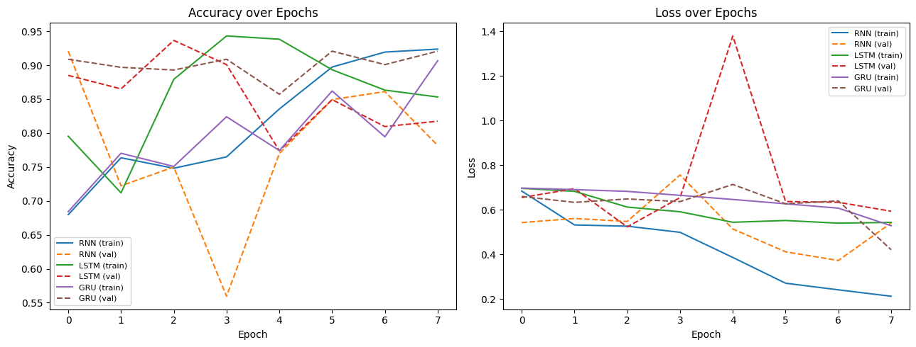
Fig 1: Training vs. Validation Accuracy and Loss, all three models (real run, 8 epochs)
Test set evaluation (threshold = 0.5, n = 630: 579 positive / 51 negative)
Model | Accuracy | Precision (pos) | Recall (pos) | F1 (pos)
RNN | 0.8063 | 0.9507 | 0.8325 | 0.8877
LSTM | 0.8317 | 0.9505 | 0.8618 | 0.9040
GRU | 0.9143 | 0.9382 | 0.9706 | 0.9542
Negative-class metrics (the minority / harder class)
Model | Precision (neg) | Recall (neg) | F1 (neg) | Support
RNN | 0.21 | 0.51 | 0.30 | 51
LSTM | 0.24 | 0.49 | 0.32 | 51
GRU | 0.45 | 0.27 | 0.34 | 51
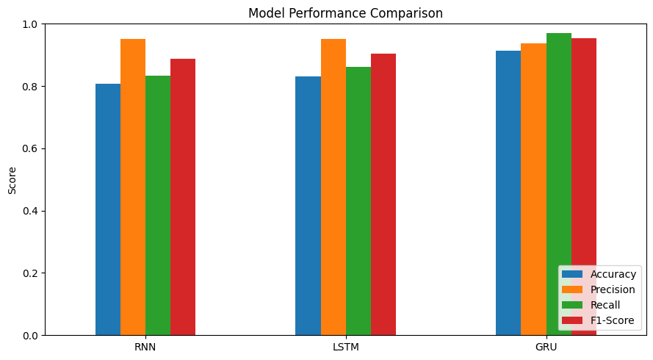
Fig 2: Model Performance Comparison — Accuracy, Precision, Recall, F1-Score (real run)
Confusion matrices (rows = actual, cols = predicted)
RNN [[ 26 25] LSTM [[ 25 26] GRU [[ 14 37]
[ 97 482]] [ 80 499]] [ 17 562]]
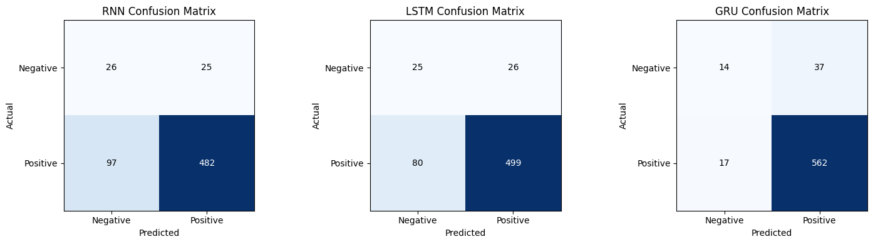
Fig 3: Confusion Matrices — RNN vs. LSTM vs. GRU (test set, n=630)
Conclusion
Under identical preprocessing, data splits, and class weighting, the choice of recurrent cell made a substantial difference on this short-review, heavily-imbalanced sentiment dataset. The plain SimpleRNN was the weakest and most unstable of the three, both during training (large validation-accuracy swings across epochs) and at test time (lowest overall accuracy, 80.6%). The LSTM improved on this but still showed a sharp overfitting spike partway through training and only a modest accuracy gain (83.2%). The GRU was clearly the strongest performer overall — 91.4% test accuracy, the most stable training curve, and the best F1-score on the dominant positive class (0.95) — while using noticeably fewer parameters than the LSTM for its gating mechanism. However, the GRU's higher overall accuracy came specifically from being much better at the positive class; it actually had the lowest recall on the minority negative class (27%) of the three models, catching only 14 of 51 negative reviews compared to 25–26 for the RNN and LSTM. This is a direct illustration of the accuracy/recall trade-off on imbalanced data: the model that looks best by aggregate accuracy is not automatically the best choice if catching negative feedback is the actual business priority. A natural next step would be to lower the GRU's decision threshold below 0.5 or increase the negative class weight further, trading some of its precision for improved negative-class recall while keeping its more stable training behaviour.

